Year 7 Art & Design- Colour Project
In this project you will be learning about colour. Within the project you will develop your colour theory including mixing colours and colour groups. The Project will then lead onto exploring the Art Movement Impressionism and how these artists used colour.

Objectives:
- To be able to identify and use appropriately key colour groups such as warm, cold, complimentary and harmonious.
- To learn how to mix colours successfully and understand which primary colours make the secondary colours.
- To be able to describe the key characteristics of Impressionism.
- To be able to apply key painting techniques and colour theory to a personal outcome.
- To be able to evaluate critically the success and developments required in their own work and the work of others.

Learning outcomes:
Colour Wheel
Warm and cold colour painting
Van Gogh’s Starry Night Sky
Van Gogh’s Sunflowers
Drawing Assessment
Landscape final piece

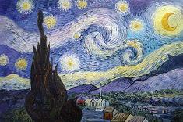
Impressionism
Keywords:
Colour, complimentary, harmonious, cold, warm, mark making, layers, impressionism, Van Gogh, printmaking, primary, secondary, tertiary, tone, tint, shade.
Useful websites:
https://www.pinterest.com/medenschool/
www.nationalgallery.org.uk/...impressionism/guide-to-impressionism
www.vangoghgallery.com
http://www.vangoghmuseum.nl/en

Independent learning:
Title Page/ Front cover
Mood board
Colour theory worksheet
Drawing of Van Gogh (mark making)
Research & Analysis into Van Gogh
Warm or cold artist copy
Spellings

Great things are done by a series of small things brought together.
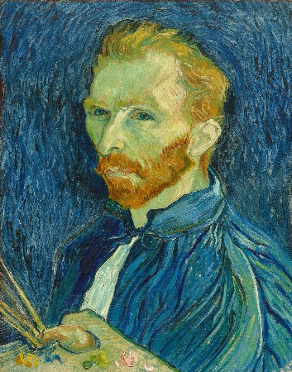

0 | 5 | 6 | 8 | 10 | 13 | 16 | 20 | 23 | 26 | 30

