Work Done - Exam Practice
Q1. The diagram shows a climber part way up a cliff.
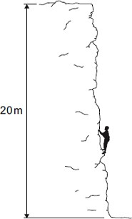
- Complete the sentence.
When the climber moves up the cliff, the climber
gains gravitational ............................................ energy.
- The climber weighs 660 N.
(i) Calculate the work the climber must do against gravity, to climb to the
top of the cliff.
...............................................................................................................
...............................................................................................................
Work done = .................................................. J
Q2. A powerlifter lifts a 180 kg bar from the floor to above his head.
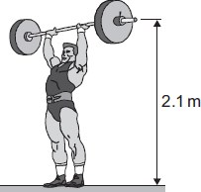
- Calculate the weight of the bar.
gravitational field strength = 10 N/kg
Show clearly how you work out your answer.
........................................................................................................................
........................................................................................................................
Weight = ............................................. N
- The powerlifter uses a constant force to lift the bar a distance of 2.1 m.
Calculate the work done by the powerlifter.
........................................................................................................................
........................................................................................................................
Work done = .............................................
- At the end of the lift, the powerlifter holds the bar stationary, above his head, for two seconds.
How much work does the powerlifter do on the bar during these two seconds?
Draw a ring around your answer.
0 90 360 900
........................................................................................................................
........................................................................................................................
Q3. The diagram shows a worker using a constant force of 60 N to push a crate across the floor.
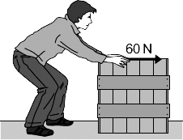
(a) The crate moves at a constant speed in a straight line
- Draw an arrow on the diagram to show the direction of the friction force acting on the moving crate.
- State the size of the friction force acting on the moving crate.
.................................................. N
Give the reason for your answer.
...............................................................................................................
...............................................................................................................
(b) Calculate the work done by the worker to push the crate 28 metres
........................................................................................................................
........................................................................................................................
Work done = ..................................................
Q4. The diagram below shows one way of lifting a bucket of bricks.
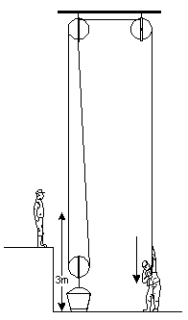
  - When the free end of the rope is pulled down, the load is lifted.
Complete the following sentence.
The work done in pulling the rope down is used to increase
the ............................ energy of the ..................................... and bricks.
  - The weight of the bricks is 100 N and they are lifted 3
Calculate the work done on the bricks.
......................................................................................................................
......................................................................................................................
Answer ............................................

Page 7 of 8

