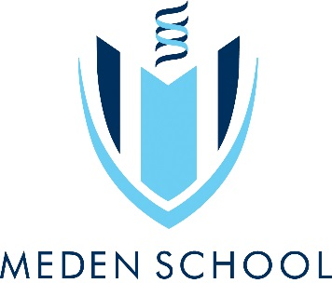
Year 8 Art & Design
In this project you will be developing your observational drawing skills by looking at Insects. The project will then lead towards a 3D outcome where you will construct a clay sculpture including insects and natural forms taken from your previous project.

Objectives:
- To learn about the qualities of different drawing materials and the importance and relevance of different approaches to drawing.
- To understand the principles of construction and decoration when using clay.
- You will be able to analyse and research the work of others and recognise key characteristics of their work.
- You will learn how to use clay safely and effectively.

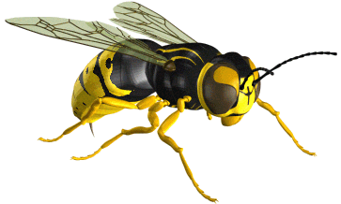
Learning outcomes:
Pencil Drawing
Colour study
Biro and texture study,
Artist Analysis
Designs
Clay Outcome

Insects & Bugs
Independent learning:
Title Page/ Front cover
Fact file
Research into Native American Totem Poles or Henri Rousseau
Totem Pole drawing
Design development

Useful websites:
https://www.pinterest.com/medenschool/
www.insects.org
www.bbc.co.uk/nature/life/Insect
www.legendsofamerica.com
www.thetotempole.co.uk

Keywords:
Symmetry, colour, tone, shape, 3D form, construct, mould, texture, mark making, decorate, totem pole, Native America, clay.
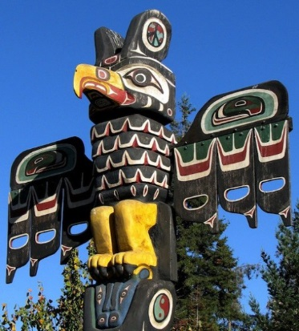
“If you are the low man on the totem pole, just remember … if it wasn’t for you the whole thing would fall over”

10 | 13 | 16 | 20 | 23 | 26 | 30 | 33 | 36 | 40

