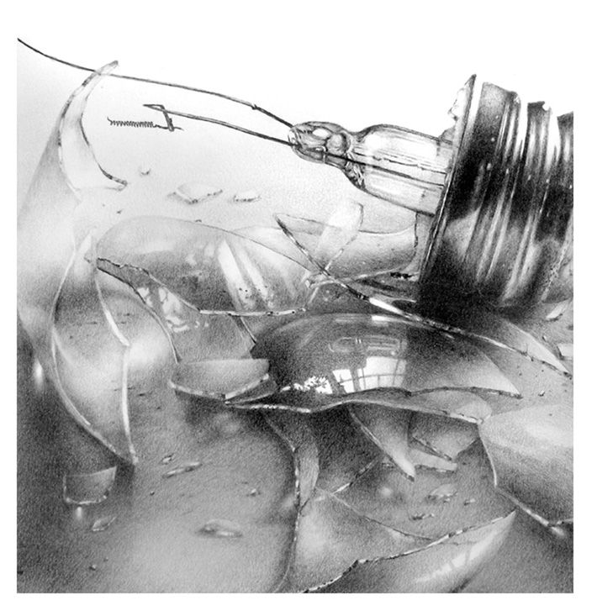
TASK ONE: Highlight 4 examples to why you think this is a good example of annotation. Next explain why you have selected those key things. The first one has been done for you.
Annotation Model Answer
In this drawing I used pencil to capture the light and the reflections in the glass. With pencil I was able to create the softer, more gradual tones I needed. I found a rubber useful to add in the highlights. I found the smaller details difficult and if I were to do this again I might work on a bigger scale to help with this. I drew a smashed light bulb because it fits into my theme of fragmentation and distortion, it shows a physical fragmentation through being broken. I could use this idea of breaking something into pieces later on. For example I could have someone look into a broken mirror to show how their view of themselves is distorted. Next I would like to explore other broken objects, perhaps a watch or a picture frame. I will take photos of these things to explore a wider range of compositions and angles to make my drawing more interesting.
 | Example from the text that you have highlighted. | Explanation to why you think it is good.
1. | In this drawing I used pencil to capture the light and the reflections in the glass. | The person has explained what materials they have used and why.
2.
3.
4.
5.
_________________________________________________________________________________________________________________________________________________________________________________________________________________________________________________________________________________________________________________________________________________________________________________________________________________________________________________________________________________________________________________________________________________________________________________________________________________________________________________________________________________________________________________________________________________________________________________________________________________________________________________________________________________________________________________________________________________________________________________________________________________________________________
TASK TWO: Now use the model answer and you key findings to help you annotate one of your drawings.
EXTENSION: Have a look at earlier examples of annotation in your sketchbook and redo ones that can be improved.

